Hinman Family Medicine
1350 Tulip Street
Longmont, CO, 80501
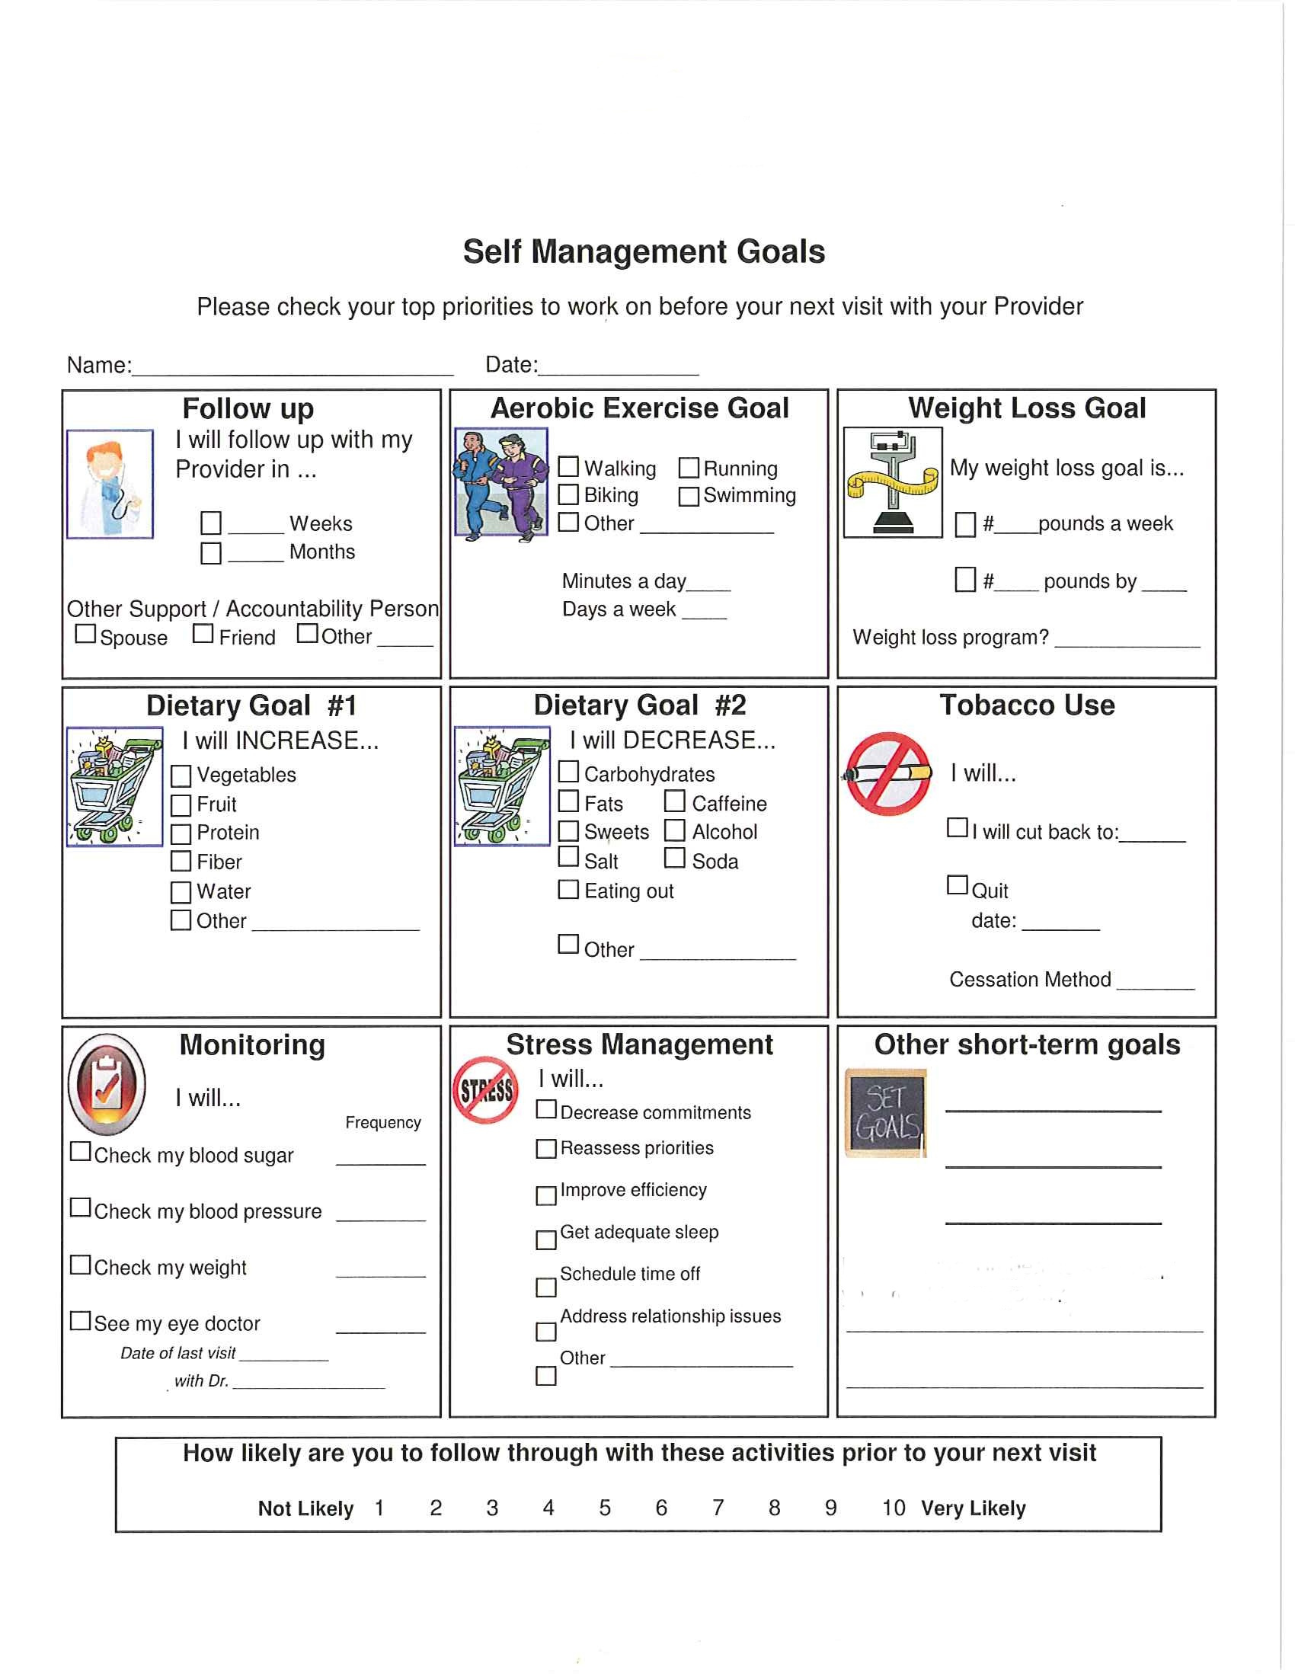
How can our staff help you meet these goals?

